

Mapúa Institute of Technology
School of Languages, Humanities and Social Sciences

A
Feasibility Study

BHENJ Internet Shop

\

Presented to:
Prof. Nestor M. Asuncion

In partial fulfillment
of the requirements in
General Economics with Taxation and Entrepreneurship
SS12/A3

Presented by:
Abanto, Nikko Adrien B.
Austria, Anthony Josh J.
Bibay, Bienvenido III F.
Chua, Marc Harold A.
Enciso, Cristelle Eunice A.

December 3, 2013
I. Introduction
Computers was developed between 1940 and 1945, however, it didn’t hooked the eyes of market at that time, being enormous in size – as big as a typical room. Due to its size, as well as the fact that it’s too pricey when it was first introduced, developing it into business wasn’t any man’s idea. It is during 1977 when personal computers – cheaper and portable features, entered the market scene and become a common thing for most of the people. It was at that time as well, when computer shops buzz its way to business industry.
Nowadays, computer shops are growing in numbers like mushrooms do. Almost every corner, especially near the universities, there are computer shops. Indeed, the increasing demand for computer rentals became the foundation of every computer shops in the country. It became a hit business venture for Filipinos in late 2000’s, because of factors such as: most of them can’t afford buying Personal Computers (PC’s) – that are definitely expensive; and it is more convenient and affordable to rent in computer shops. Due to these reasons, modern era lead computers into becoming inevitable and indispensable in the lives of people especially for students – that helps them in their typing jobs – written reports, thesis, papers and the like. These ceased the need for typewriters. Moreover, its popularity was intensified when Internet becomes available for people. From an auxiliary thing for some people, it became a necessity already. And as demands for computers increases, the number of computer shops continuously grow as well – to provide the services that people need.
Indeed, computers shops are famous in their brand of market. Features of these businesses includes: Web Browsing with the use of internet, PC Gaming, Word Processing Tools, and much more. Of course, every business evolves, that’s why variations of this business was created such as Internet Cafés, PisoNet and the like.

a. Name of the Firm
i.
Name: “BHENJ Internet Shop”
ii.
The name of the Firm, as planned and decided by the team, is “BHENJ Internet Shop”. It was derived from linking the first letters of the name of each member of the group: Bienvenido (B), Harold (H), Eunice (E), Nikko (N) and Josh (J). We came up with this name upon contemplating that the best way to manifest the great bond of our friendship is through connecting our names and yielding a single and unified name.
iii.
The internet shop will then be registered with Department of Trade and Industry (DTI). We will seek for easier registration through the latest mode as what DTI is now implementing which is the Philippine Business Registry (PBR) – a faster way to register business whether sole proprietorship, partnership or corporation. This ensures that the expected business registration of long period will cut down to 30 minutes only (for sole proprietorships only), as promised by the DTI though the help of Securities and Exchange Commission (SEC) and some local government units (LGUs). Moreover, the said firm will be registered as sole proprietorship for easier registration.

b. Nature of Business
The firm, essentially, is a computer/internet shop that provides internet services to its customers, as well as other basic services. Computers sets are installed with applications that people especially students would need in their paper works, assignments and etc. Added to the given services, the internet shop caters, as well; printing services (Black and White, and Colored), CD (Compact Disc)/DVD Burn and other extra services. What is unique with this computer shop is that it provides PisoNet feature – people would rent computers by inserting coins in the machine. This ensures that the computer shop would get the market demand for affordable computer rentals. Indeed, there are already PisoNet Shops and there are Computer Shops but there is none yet that have the combined feature of two. Thus, providing a more flexible options to its customers. With the services that the firm/Internet Shop would provide, people would have a wider options on how much time they’ll use in rentals and the like.

c. Location of the Firm
i.
Location: Ipilan Tayabas, Quezon
ii.
The Internet Shop would be situated at Ipilan Tayabas, Quezon. Due to the fact that we don’t own the space, we decided to pay a monthly rent to its owner considering that the space have been unoccupied for some time. The location of the said firm would be the vital reason of its success for it is near from a High School – Luis Palad National High School. It is, as well, near from Skyway; and many communities/barangays are situated. Moreover, with 91,428 people (According to 2010 National Statistics Office (NSO) census) living in the said place, the Internet Shop would definitely become a hit. The location of the firm would yield greater earnings due to the fact that few computer shops are yet present in the said place.

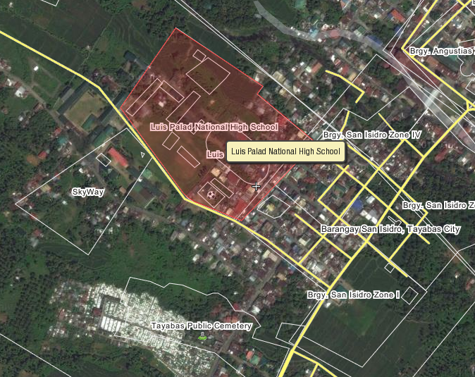
Figure 1.1. Location of the Firm
iii.
The target of the firm (Internet Shop) are the people living near the area with the most importance to the students and office workers that have been longing for computers hops to open in their place. This will be of great help to those people and would be a good chance for the business to grow eventually, providing more services later.

II. Competition/Marketing
- Similar businesses within the location
We have said earlier that our internet shop will be renting a space along Ipilan, Tayabas, Quezon near Luis Palad National High School. As far as we know, there will be a lot of competitive internet shops within the school’s campus, knowing that students and teachers have a huge amount of demand in using the computers since this is not an urban type of community. Although there are internet shops within the school’s campus, our internet shop will gather attention to the consumers because we have that “pisonet” wherein you can afford to use internet with your coins in an inexpensive way.

- Edge over the others
Our internet shop will be having an affordable normal rate of 15php per hour and we have an option called “pisonet” or “tingi net” wherein your 1 peso will be equivalent to 3 minutes usage of internet. This “tingi net” will benefit those consumers who can’t afford to pay the 15php rate per hour of internet usage and this option will have a huge impact to the consumers knowing that Filipino's tend to enjoy the idea of "retail", thinking that they'll pay less for a period of time. Moreover, our internet shop also offer affordable price of services that will surely satisfy your needs.

- Marketing strategies
In order for our internet shop to be exposed to the people, we will place a large tarpaulin with our name printed on it outside our shop. With this large tarpaulin, people will immediately know about us. Moreover, we will also post some printed ads with the lists of services that we offer as well as the name of our internet shop with its address too. These printed ads will be posted along the streets and near the skyway which contains a lot of people passing by.

III. Raw Materials
IV.

